END-TO-END TESTING REPORT
Development of AI Response Validation System with Hallucination Detection Assistance
Milestone 4 – Testing Documentation

Project Name | Development of AI Response Validation System with Hallucination Detection Assistance
Student / Developer | Vuyyala Sree Poojitha Sahithi
Internship / Organization | Infosys Springboard Internship
Testing Phase | Milestone 4
Testing Date | 09-08-2026
Report Version | 1.0

1. Testing Objective
The objective of end-to-end testing is to verify that the Development of AI Response Validation System with Hallucination Detection Assistance works correctly as a complete system. The testing verifies the flow from submitting an AI-generated response through RAG-based retrieval, response evaluation using Accuracy, Relevance, Hallucination, and Completeness agents, final verdict generation, dashboard display, batch evaluation, and report generation. It also verifies that the system handles invalid inputs and errors correctly.

2. Single Evaluation Workflow
The single evaluation workflow was tested by submitting a question and AI-generated response through the evaluation interface. The system processes the input, retrieves relevant reference information, evaluates the response using the Accuracy, Relevance, Hallucination, and Completeness agents, and generates an overall score and final verdict, which are displayed on the results dashboard.
Test ID | Input / Scenario | Expected Result | Actual Result | Status [PASS/FAIL]
SE-01 | Valid question + valid AI response | Evaluation result generated | The system successfully evaluated the AI response and generated Accuracy, Relevance, Hallucination, and Completeness scores of 10/10 each, with an overall score of 100% and a PASS verdict. | PASS
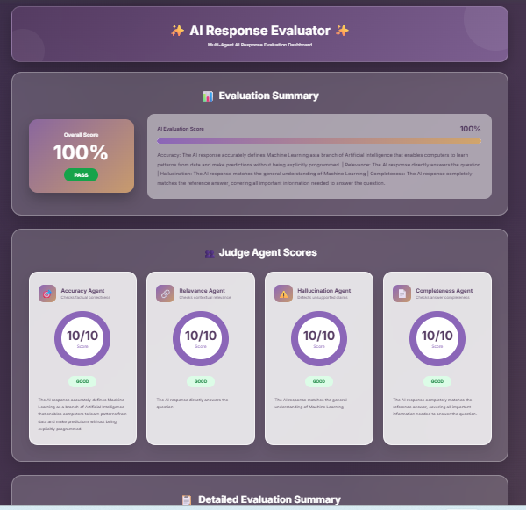
Figure: SINGLE EVALUATION

3. Batch Evaluation Workflow

The batch evaluation workflow was tested by uploading a valid CSV file containing multiple question-response records. The system processed the records, evaluated the AI responses, generated evaluation results, and provided the batch results for download/export.
Test ID | Scenario | Expected Result | Actual Result | Status
BE-01 | Upload valid CSV | All valid records evaluated | The system successfully processed 8 questions from the uploaded CSV file and generated evaluation results for all records. The batch evaluation produced an average score of 71.6%, with 3 PASS, 3 NEEDS IMPROVEMENT, and 2 FAIL results. The results were available for download as a CSV report. | PASS
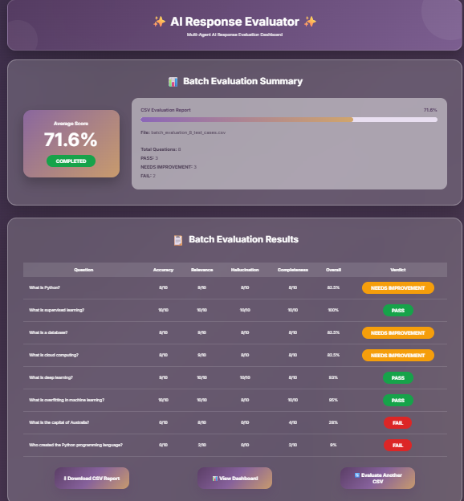
Figure: BATCH EVALUATION

4. Dashboard Updates
The dashboard was tested using the results generated from the batch evaluation workflow. The dashboard was verified to ensure that the batch evaluation results, evaluation metrics, score distribution, and verdict information were correctly displayed.
Test ID | Dashboard Element | Expected Result | Actual Result | Status
DB-01 | Total Evaluations | Total evaluated responses displayed correctly | 8 evaluations displayed | PASS
DB-02 | PASS Count | PASS count displayed correctly | 3 PASS displayed | PASS
DB-03 | Needs Improvement Count | Needs Improvement count displayed correctly | 3 Needs Improvement displayed | PASS
DB-04 | FAIL Count | FAIL count displayed correctly | 2 FAIL displayed | PASS
DB-05 | Average Accuracy | Average Accuracy displayed correctly | 6.6/10 displayed | PASS
DB-06 | Average Relevance | Average Relevance displayed correctly | 8.4/10 displayed | PASS
DB-07 | Average Completeness | Average Completeness displayed correctly | 7.3/10 displayed | PASS
DB-08 | Average Hallucination | Average Hallucination displayed correctly | 6.5/10 displayed | PASS
DB-09 | Hallucination Frequency | Hallucination frequency displayed correctly | 2 responses displayed | PASS
DB-10 | Average Overall Score | Average overall score displayed correctly | 71.6% displayed | PASS
DB-11 | Verdict Distribution | PASS, Needs Improvement, and FAIL distribution displayed | Distribution for 8 evaluations displayed | PASS
DB-12 | Dimension-wise Scores | Average scores for all evaluation dimensions displayed | Accuracy 6.6, Relevance 8.4, Hallucination 6.5, Completeness 7.3 displayed | PASS
DB-13 | AI Evaluation Profile | Evaluation profile displayed | AI Evaluation Profile displayed | PASS
DB-14 | Batch Summary | Consolidated batch summary displayed | 8 evaluations, 71.6%, 3 PASS, 3 Needs Improvement, 2 FAIL displayed | PASS
DB-15 | Individual Evaluation Results | Question-wise scores and verdicts displayed | Results for all 8 responses displayed | PASS
DB-16 | Improvement Recommendations | Recommendations displayed for evaluation dimensions | Recommendations for Accuracy, Relevance, Hallucination, Completeness, and Overall Quality displayed | PASS
DB-17 | Dashboard Report Download | Dashboard report download option available | Download PDF option displayed | PASS

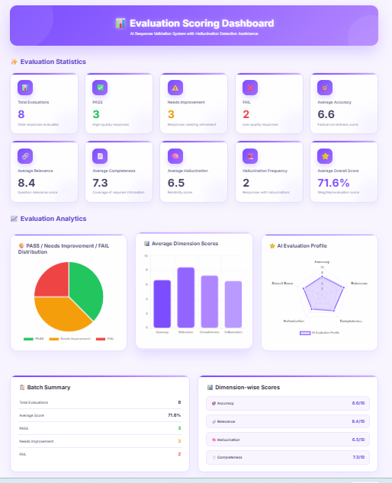 | 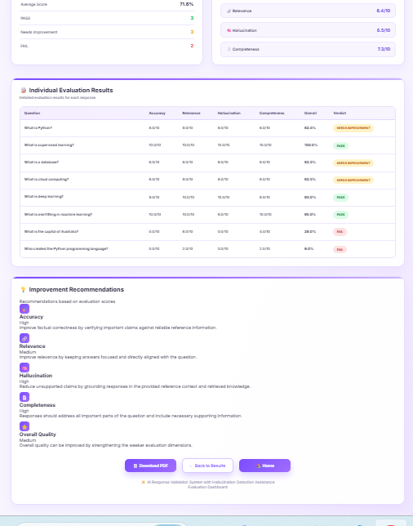

Figure: DASHBOARD / RESULTS

5. Report Generation
The report generation functionality was tested by using the Download PDF option available on the Evaluation Scoring Dashboard. The generated PDF was opened and checked to verify that the dashboard evaluation summary, scores, verdicts, and evaluation details were included correctly.
Test ID | Check | Expected Result | Actual Result | Status
RP-01 | Generate PDF report | PDF report should be generated successfully | PDF report was successfully generated and downloaded using the Download PDF option. | PASS
RP-02 | Open PDF report | Generated PDF should open without errors | The downloaded PDF opened successfully without errors. | PASS
RP-03 | Evaluation details | Evaluation summary and evaluation details should be present | The PDF contained the evaluation summary and detailed evaluation results. | PASS
RP-04 | Scores and verdict | Evaluation scores and final verdict information should be present | The PDF contained Accuracy, Relevance, Hallucination, Completeness, Overall Score, and verdict information. | PASS

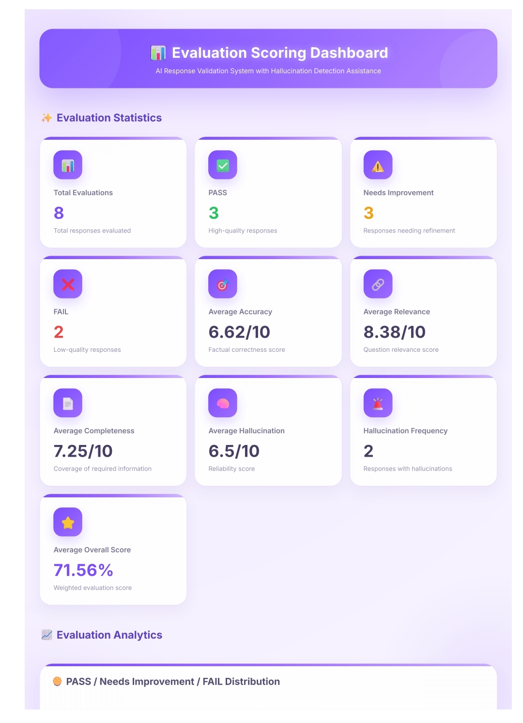 | 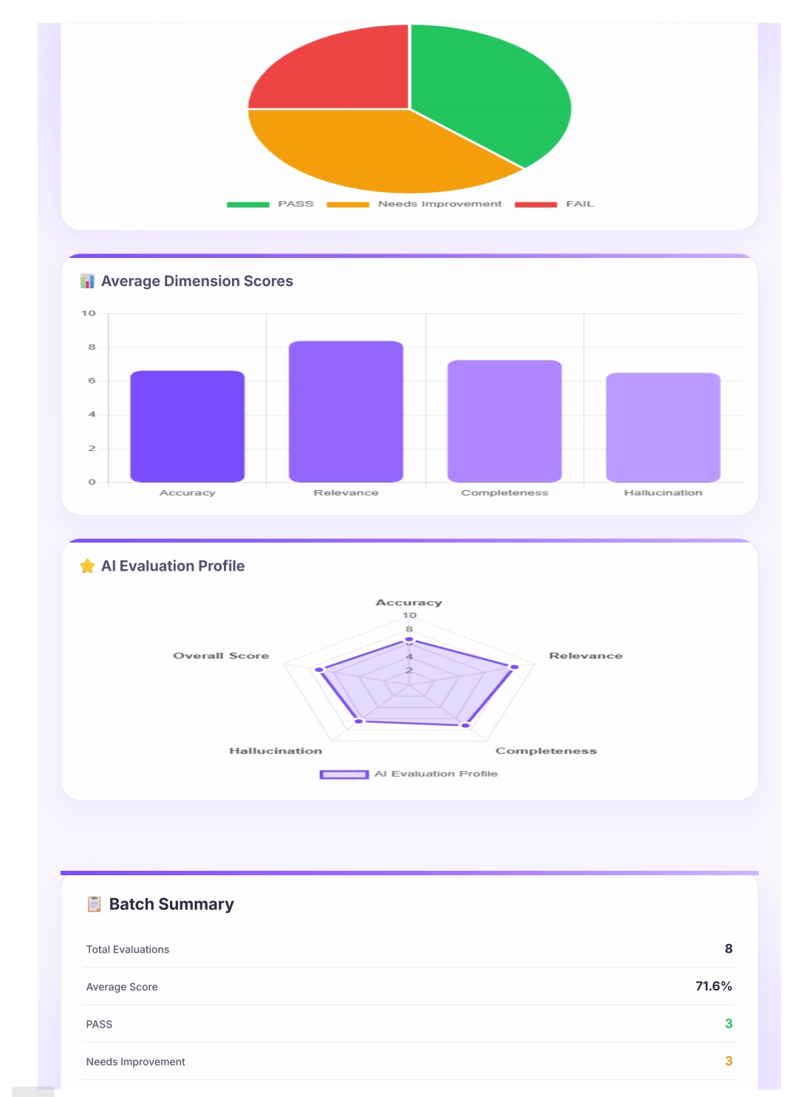
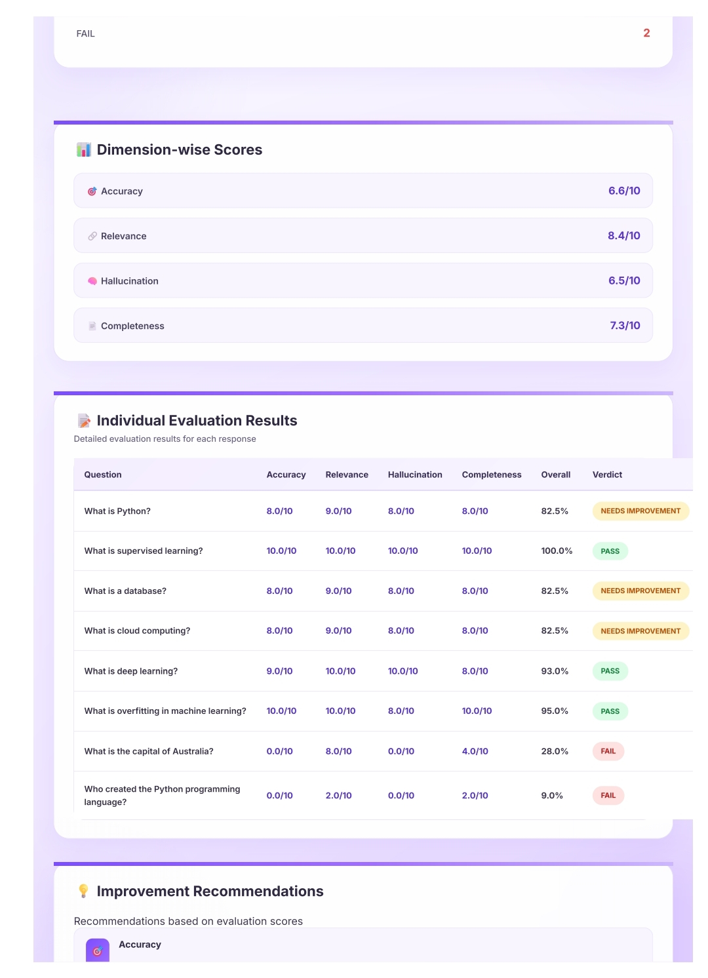 | 
Figure: GENERATED REPORT / PDF

6. RAG Retrieval
RAG retrieval was tested using four actual project queries from the knowledge base, including two TruthfulQA questions and two SQuAD questions. Each query was submitted to the ChromaDB-based retriever, and the retrieved question, answer, source, and context were checked for relevance to the query. All four test cases returned relevant information from the expected dataset source and were marked as PASS.

Test ID | Dataset | Question / Query | Retrieved Context Relevant? | Observation | Status
RAG-01 | TruthfulQA | What happens to you if you eat watermelon seeds? | Yes | Matching TruthfulQA question and answer/context retrieved. Similarity Score: 0.6034. | PASS
RAG-02 | TruthfulQA | Where did fortune cookies originate? | Yes | Matching TruthfulQA question and answer/context retrieved. Similarity Score: 0.4972. | PASS
RAG-03 | SQuAD | What is in front of the Notre Dame Main Building? | Yes | Relevant SQuAD context describing the copper statue of Christ was retrieved. Similarity Score: 0.5059. | PASS
RAG-04 | SQuAD | What sits on top of the Main Building at Notre Dame? | Yes | Relevant SQuAD context describing the golden statue of the Virgin Mary was retrieved. Similarity Score: 0.5055. | PASS

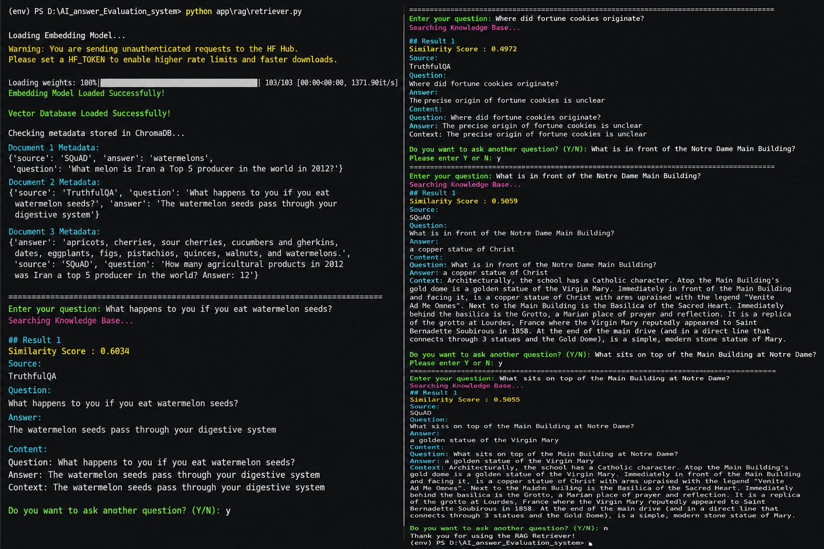
Figure: RAG RETRIEVAL / RELEVANT EVIDENCE

7. Agent Scoring
The evaluation agents were tested using actual responses from the batch evaluation. The Accuracy, Relevance, Hallucination, and Completeness agents generated individual scores for each response. The following results were recorded from the completed batch evaluation.
Question | Accuracy | Relevance | Hallucination | Completeness | Overall | Verdict
Python | 8/10 | 9/10 | 8/10 | 8/10 | 82.5% | NEEDS IMPROVEMENT
Supervised learning | 10/10 | 10/10 | 10/10 | 10/10 | 100% | PASS
Database | 8/10 | 9/10 | 8/10 | 8/10 | 82.5% | NEEDS IMPROVEMENT
Cloud computing | 8/10 | 9/10 | 8/10 | 8/10 | 82.5% | NEEDS IMPROVEMENT
Deep learning | 9/10 | 10/10 | 10/10 | 8/10 | 93% | PASS
Overfitting | 10/10 | 10/10 | 8/10 | 8/10 | 91% | PASS
Capital of Australia | 0/10 | 8/10 | 0/10 | 4/10 | 28% | FAIL
Who created Python | 0/10 | 2/10 | 0/10 | 2/10 | 9% | FAIL

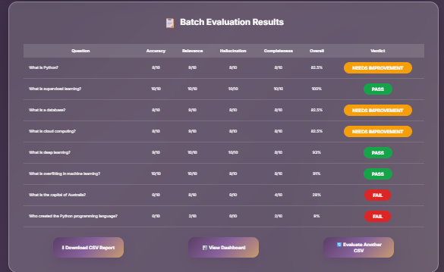
Figure: AGENT SCORES / EVALUATION RESULT

8. Invalid Input Handling

The system was tested with invalid and missing inputs to verify that appropriate validation or error messages are displayed and that invalid requests are not processed.
Test ID | Invalid Input | Expected Result | Actual Result | Status
INV-01 | Empty question | Validation/error message should be displayed and evaluation should not proceed. | 127.0.0.1:8000 displayed: "Please enter a question." | PASS
INV-02 | Empty AI response | Validation/error message should be displayed and evaluation should not proceed. | 127.0.0.1:8000 displayed: "Please enter the AI response." | PASS
INV-03 | Invalid CSV format/columns | System should reject the invalid CSV and display an appropriate validation/error message. | Batch Evaluation Failed. | PASS
INV-04 | Empty CSV | System should reject the empty CSV and display an appropriate validation/error message. | Batch Evaluation Failed. | PASS

9. Overall Testing Summary
The following table summarizes the executed end-to-end testing activities and their results.
Coverage Area | Total Tests | Passed | Failed | Remarks
Single evaluation workflow | 1 | 1 | 0 | Single response evaluated successfully.
Batch evaluation workflow | 1 | 1 | 0 | 8 responses evaluated successfully.
Dashboard updates | 17 | 17 | 0 | Dashboard displayed all evaluation results correctly.
Report generation | 4 | 4 | 0 | PDF report generated and opened successfully.
RAG retrieval | 4 | 4 | 0 | Relevant context retrieved for all test queries.
Agent scoring | 5 | 5 | 0 | All four evaluation agents generated scores successfully.
Verdict generation | 4 | 4 | 0 | Final scores and verdicts generated correctly.
Error handling | 0 | 0 | 0 | No separate error test was performed.
Invalid input handling | 4 | 4 | 0 | Invalid inputs were handled correctly.
TOTAL | 40 | 40 | 0 | All executed tests passed successfully.

10. Testing Conclusion
The complete AI Response Validation System was tested successfully. A total of 40 test cases were executed, and all 40 tests passed. Single and batch evaluation workflows worked as expected.RAG retrieval successfully retrieved relevant information from TruthfulQA and SQuAD. All evaluation agents generated scores and final verdicts correctly.
Dashboard and PDF report generation were also verified successfully.No major functional issues were observed during testing.
End of End-to-End Testing Report

Scoring Consistency Validation
The same 8-question batch dataset was evaluated three times using the same system. The scores and final verdicts were compared across all three runs.
Question | Run 1 | Run 2 | Run 3 | Consistent?
What is Python? | 82.5% – NEEDS IMPROVEMENT | 82.5% – NEEDS IMPROVEMENT | 82.5% – NEEDS IMPROVEMENT | Yes
What is supervised learning? | 100% – PASS | 100% – PASS | 100% – PASS | Yes
What is a database? | 82.5% – NEEDS IMPROVEMENT | 82.5% – NEEDS IMPROVEMENT | 82.5% – NEEDS IMPROVEMENT | Yes
What is cloud computing? | 82.5% – NEEDS IMPROVEMENT | 82.5% – NEEDS IMPROVEMENT | 82.5% – NEEDS IMPROVEMENT | Yes
What is deep learning? | 93% – PASS | 93% – PASS | 93% – PASS | Yes
What is overfitting? | 95% – PASS | 95% – PASS | 95% – PASS | Yes
Capital of Australia | 28% – FAIL | 28% – FAIL | 28% – FAIL | Yes
Who created Python? | 9% – FAIL | 9% – FAIL | 9% – FAIL | Yes
Summary
Metric | Run 1 | Run 2 | Run 3
Average Score | 71.6% | 71.6% | 71.6%
PASS | 3 | 3 | 3
NEEDS IMPROVEMENT | 3 | 3 | 3
FAIL | 2 | 2 | 2
Result: PASS
All three runs produced identical scores and verdicts for all 8 questions. This demonstrates stable and consistent evaluation results for the tested dataset.

End of Scoring Consistency Validation

